Given a string s, find two **disjoint palindromic subsequences** of s such that the **product** of their lengths is **maximized**. The two subsequences are **disjoint** if they do not both pick a character at the same index.

Return *the* ***maximum*** *possible* ***product*** *of the lengths of the two palindromic subsequences*.

A **subsequence** is a string that can be derived from another string by deleting some or no characters without changing the order of the remaining characters. A string is **palindromic** if it reads the same forward and backward.

**Example 1:**

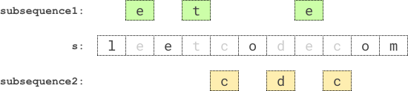

Input: s = "leetcodecom"  
Output: 9  
Explanation: An optimal solution is to choose "ete" for the 1st subsequence and "cdc" for the 2nd subsequence.  
The product of their lengths is: 3 * 3 = 9.

**Example 2:**

Input: s = "bb"  
Output: 1  
Explanation: An optimal solution is to choose "b" (the first character) for the 1st subsequence and "b" (the second character) for the 2nd subsequence.  
The product of their lengths is: 1 * 1 = 1.

**Example 3:**

Input: s = "accbcaxxcxx"  
Output: 25  
Explanation: An optimal solution is to choose "accca" for the 1st subsequence and "xxcxx" for the 2nd subsequence.  
The product of their lengths is: 5 * 5 = 25.

**Constraints:**

* 2 <= s.length <= 12
* s consists of lowercase English letters only.